Infrared (IR) spectroscopy

* Measures the absorption of infrared light, which causes molecular vibration (stretching, bending, twisting, and folding)
* IR spectra are generally plotted as percent transmittance vs wavenumber (1/λ)
  + The normal range of a spectrum is 4000 to 400cm-1
  + The fingerprint region is between 1500 and 400cm-1. It contains a number of peaks that can be used by experts to identify a compound
* To appear on an IR spectrum, vibration of a bond must change the bond dipole moment
  + Those composed of atoms with the same electronegativity or molecules that are symmetrical therefore do not not exhibit absorption
* Important characteristic absorptions
  + The O-H bond is a **broad peak** around 3300cm-1
    - E.g. alcohols, water, and carboxylic acids
    - The carboxylic acid O-H peak will be shifted around 3000cm-1
  + The N-H peak is a **sharp peak** around 3300cm-1
    - E.g. some amines, imines, and amides
  + The C=O peak is a **sharp peak** around 1750cm-1
    - E.g. aldehydes, ketones, carboxylic acids, amides, esters and anhydrides
* Higher-order bonds tend to have higher absorption frequencies, so loss of double-bond character should decrease the absorption frequency of the group
  + E.g. C=O groups in conjugation with double bonds tend to absorb at lower wavenumbers because the delocalization of π electrons causes the C=O bond to lose double-bond character, shifting the stretching frequency closer to C-O stretches
* Enantiomers will have identical IR spectra because they have the same functional groups and will therefore have the exact same absorption frequencies
  + They have opposite specific rotations, but specific rotation actually has no effect on the IR spectrum
* **Amino acids in their fully protonated form contain these three important peaks:**
  + **O-H (broad peak at 3000cm-1)**
    - **The C=O bond withdraws electron density from the O-H bond, shifting the absorption frequency down from 3300cm-1 to 3000cm-1**
  + **N-H (sharp peak at 3300cm-1)**
  + **C=O (sharp peak at 1750cm-1)**

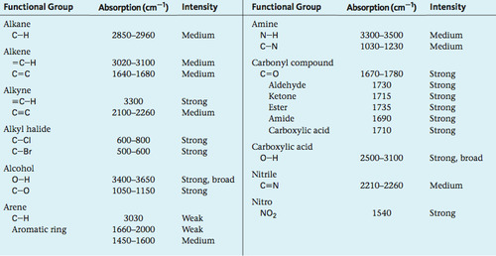

Ultraviolet (UV) spectroscopy

* Measures absorption of UV light, which causes movement of electrons between molecular orbitals
* Most useful for studying compounds containing **double bonds** or heteroatoms with lone pairs that create **conjugated systems**
* Generally plotted as percent transmittance or absorbance vs wavelength
* To appear on a UV spectrum, a molecule must have a small enough energy difference between its **highest occupied molecular orbital (HOMO)** and its **lowest unoccupied molecular orbital (LUMO)** to permit an electron to move from one orbital to the other
  + The smaller the difference between HOMO and LUMO, the longer the wavelengths a molecule can absorb (E=hf, so lower E means larger wavelength)
  + Conjugation shifts the absorption spectrum to higher maximum wavelengths (lower frequencies)

Nuclear Magnetic Resonance (NMR) spectroscopy

* Measures the alignment of magnetic spin with an applied magnetic field, which depends on the magnetic environment of the nucleus itself
  + Useful for determining the **structure (connectivity)** of a compound, including functional groups
  + Nuclei may be in the lower-energy α-state or higher-energy β-state; radiofrequency pulses push the nucleus from the α-state to the β-state, and these frequencies can be measured
* NMR spectra are generally plotted as frequency vs absorption of energy. They are standardized by using **chemical shifts (δ)**, measured in ppm of spectrometer frequency
  + NMR spectra are calibrated using tetramethylsilane (TMS), which has a chemical shift of 0ppm
  + Higher chemical shifts are located to the left (downfield); lower chemical shifts are located to the right (upfield)

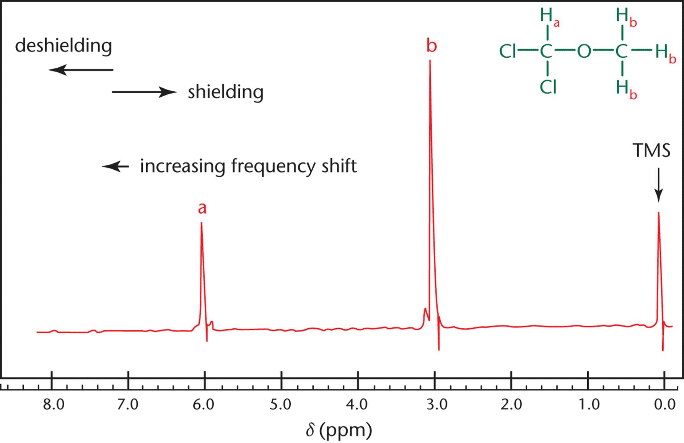

Proton (1H) NMR

* Each unique group of protons has its own peak
* The integration (area under the curve) of this peak is proportional to the number of protons contained under the peak
* **Deshielding** of protons occurs when the **electron-withdrawing groups** pull electron density away from the nucleus → allows it to be more easily affected by the magnetic field → moves a peak further downfield
* When **hydrogens are on adjacent atoms**, they interfere with each other’s magnetic environment, causing **spin-spin coupling (splitting)**
  + A proton’s (group of protons’) peak is split into n+1 subpeaks, where n is the number of hydrogens on the adjacent carbon
  + Splitting patterns include doublets, triplets, and multiplets

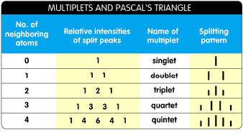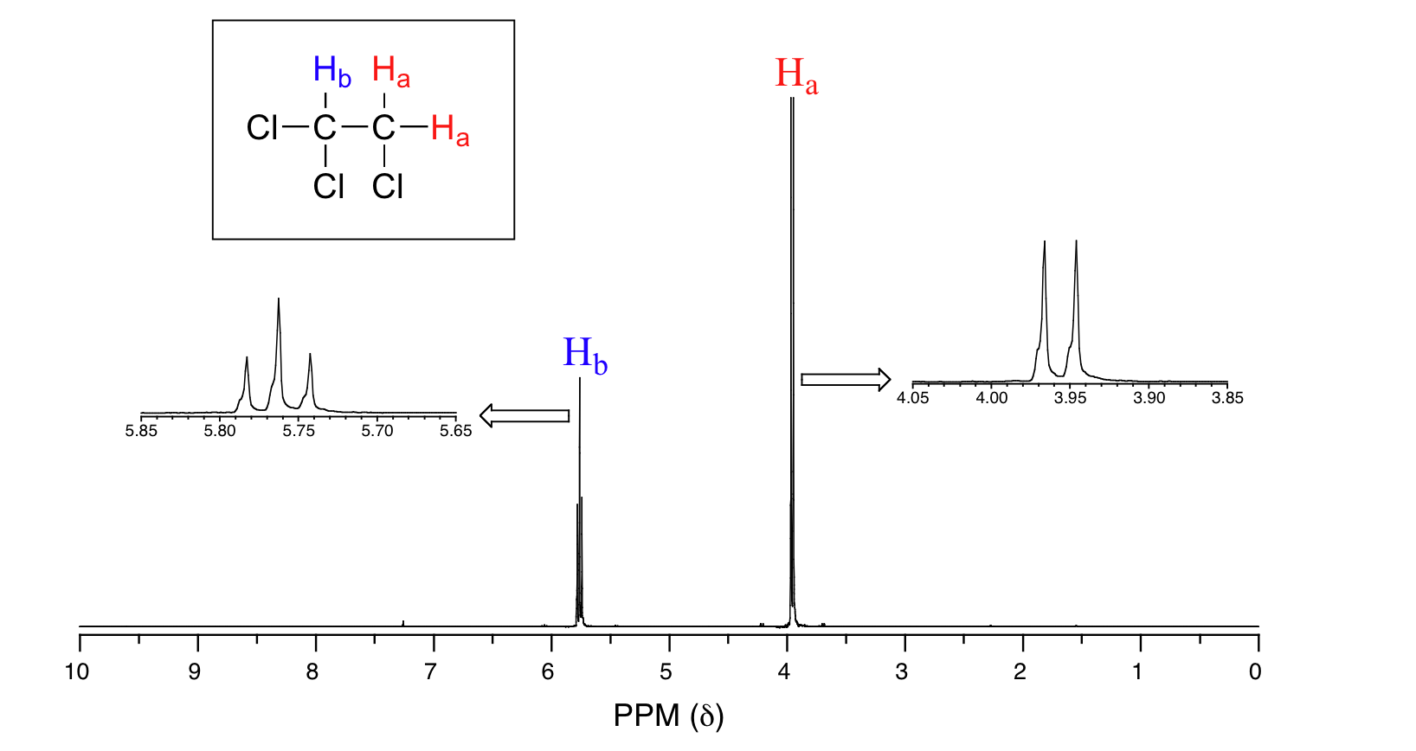

* The more electron density that is pulled away from the proton, the more deshielded it will be and the further downfield the proton will appear → higher chemical shift to the left
  + The highlighted ones are more commonly tested

